Install MiniKube on Windows

Install Docker for Desktop

1. Enable Windows required features. Search Turn Windows features on or off in the Windows search bar.

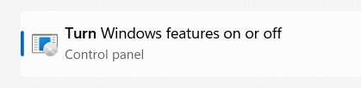

1. Click to open the utility. Following Window opens.

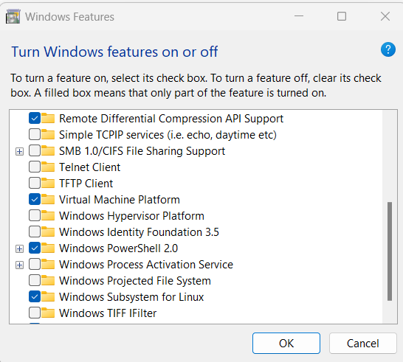

1. Scroll down to bottom. Select the check boxes for the features Windows Hypervisor Platform and Windows Subsystem for Linux.





Click OK. Once the installation is done, it will ask you to restart the system.

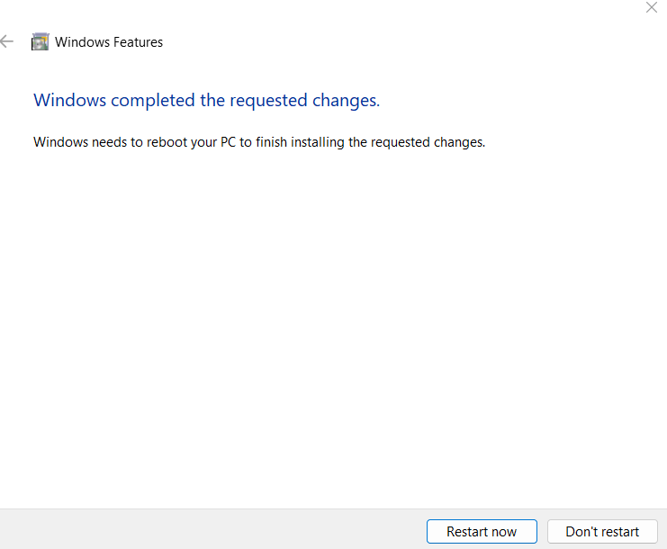

Click Restart Now.

Once the machine restart login.

1. Download Docker for Desktop. Go to the following URL

<https://docs.docker.com/desktop/setup/install/windows-install/>

And select 

Once the download completes. Double click the file to start the installation.

1. The following window opens. Click Ok.

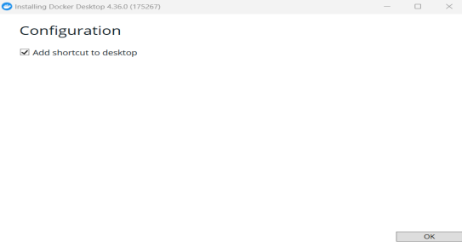

1. It will start unpacking files as shown below.

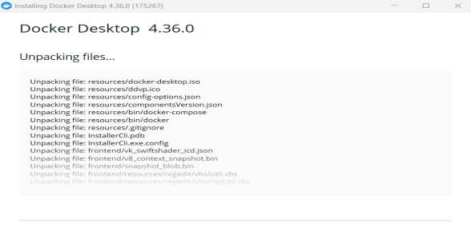

1. Finally after the installation is complete, you get the screen which will ask you to close and logout. Click close and logout.
2. Once you login. Search for Docker Desktop.



Click to start. You may have start it with run as Administrator option (Right click to get this option).

1. The following window is displayed.

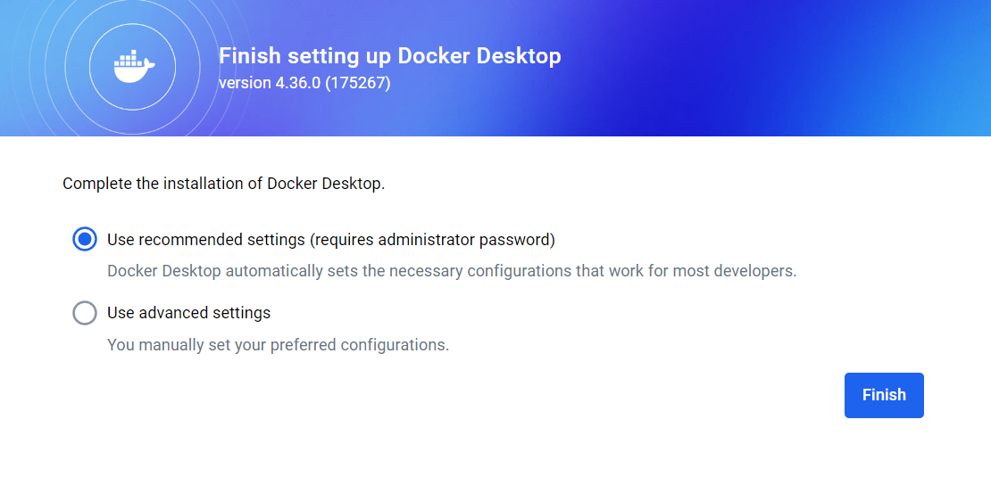

Click Finish.

1. Next the following window is displayed.

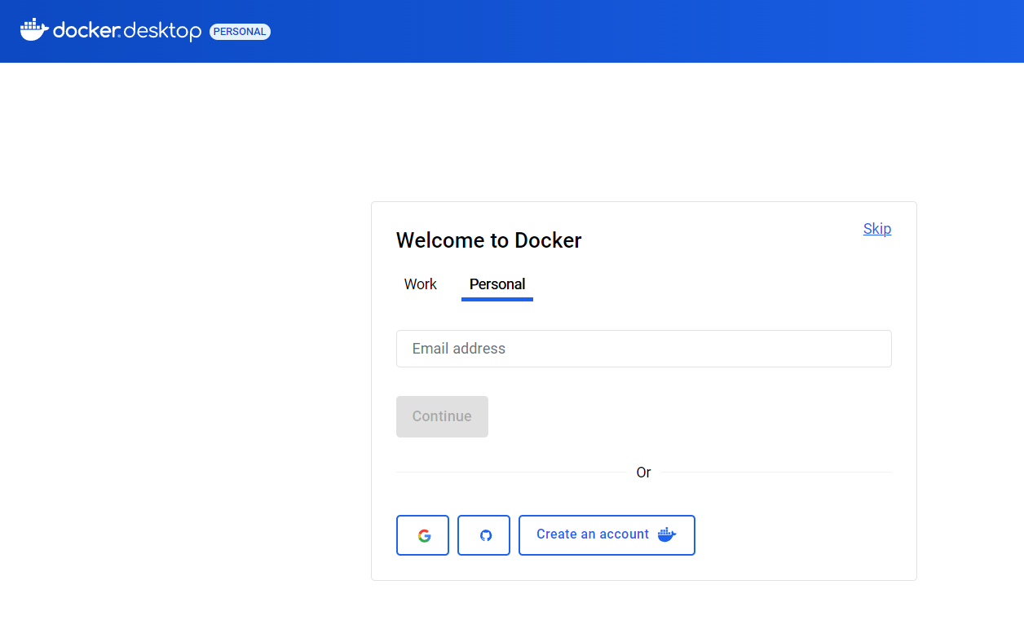

If you are going to log in, then make sure you select the personal tab as shown above.

Else skip the process by clicking the skip option

Skip the next screen also.

1. The following window opens.

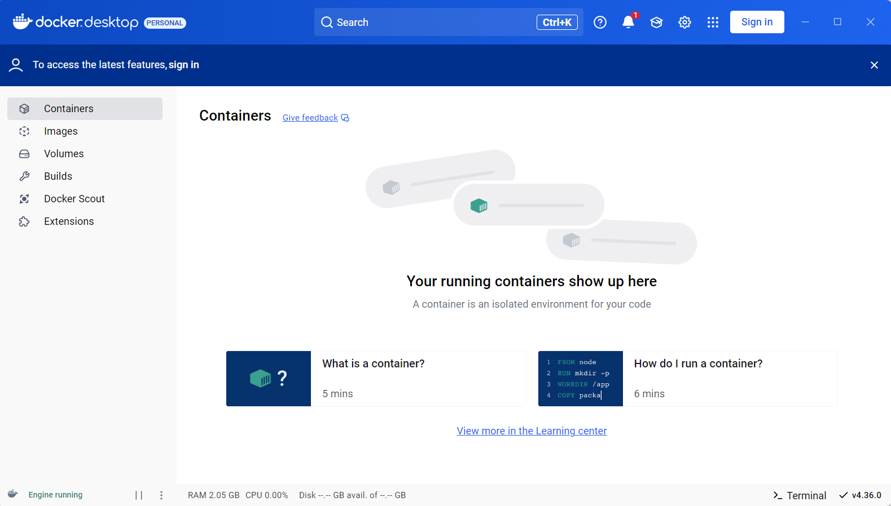

It means the Docker Desktop for Windows is successfully installed. Make sure you keep this window open in the background.

1. Verify by opening a command prompt and running following commands. If you get any error, close the command prompt and open it using Run as administrator option.

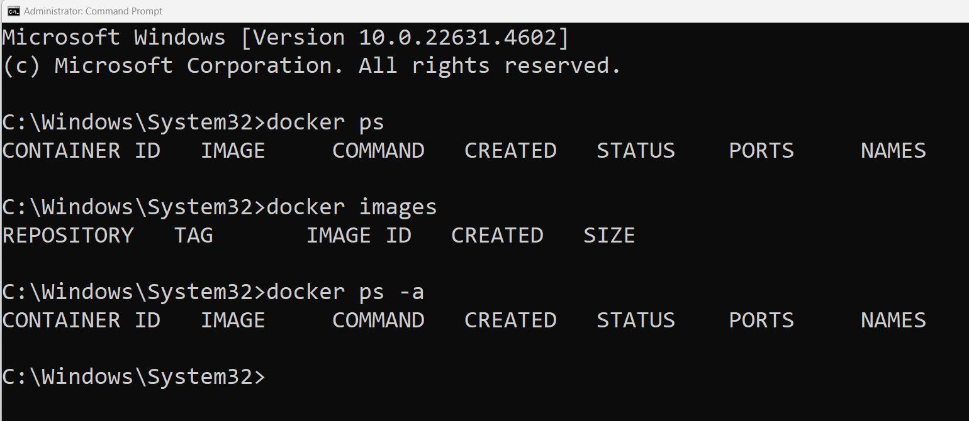

Install MiniKube

1. Open Poweshell by typing powershell into search . Right click and select Run as Administrator.

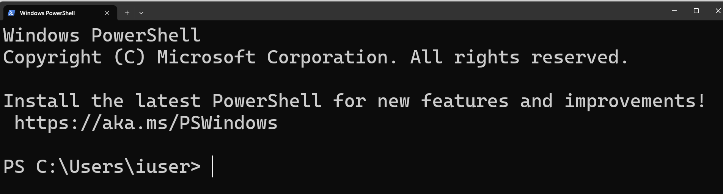

1. Install chocolatey package manager into windows to install Kubectl. Copy paste following command in the powershell terminal.

Set-ExecutionPolicy Bypass -Scope Process -Force; [System.Net.ServicePointManager]::SecurityProtocol = [System.Net.ServicePointManager]::SecurityProtocol -bor 3072; iex ((New-Object System.Net.WebClient).DownloadString('https://community.chocolatey.org/install.ps1'))

1. Now install kubectl using chocolatey package manager.

choco install kubernetes-cli

You may get a screen as shown below.

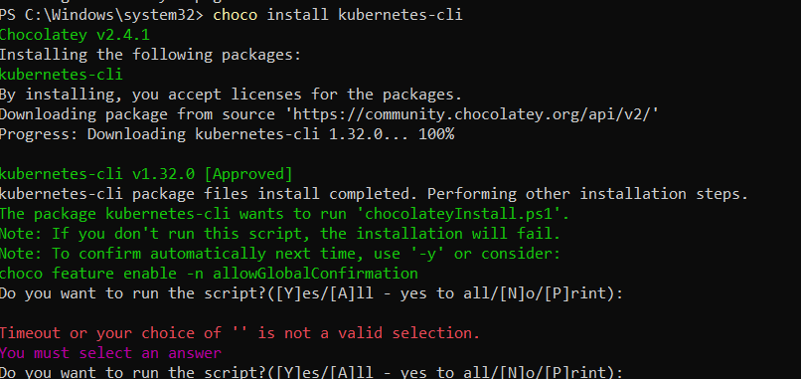

Type yes.

1. Verify the installation using following command.

kubectl version --client

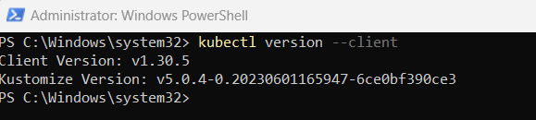

1. Create the .kube directory where all the configurations are saved into

cd C:\Users\<loggedin_user_folder>

mkdir .kube

Go to the .kube directory you just created by the following command:

cd .kube

Create the configuration file in the .kube folder by PowerShell Command:

New-Item config -type file

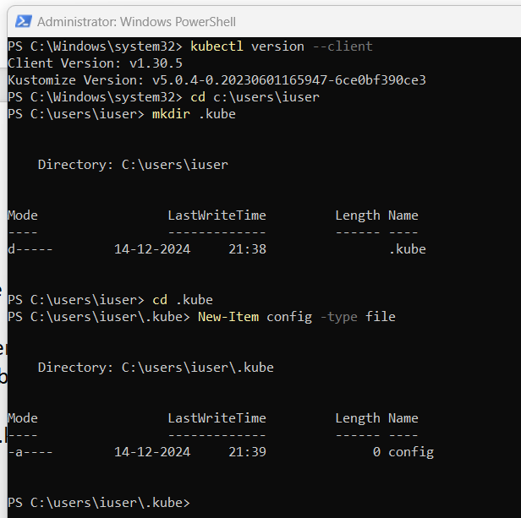

1. Install minikube.

Open Powershell with run as administrator option. Copy and paste following command.

New-Item -Path 'c:\' -Name 'minikube' -ItemType Directory -Force

Invoke-WebRequest -OutFile 'c:\minikube\minikube.exe' -Uri 'https://github.com/kubernetes/minikube/releases/latest/download/minikube-windows-amd64.exe' -UseBasicParsing

Once the above command completes, enter the following command.

$oldPath = [Environment]::GetEnvironmentVariable('Path', [EnvironmentVariableTarget]::Machine)

if ($oldPath.Split(';') -inotcontains 'C:\minikube'){

[Environment]::SetEnvironmentVariable('Path', $('{0};C:\minikube' -f $oldPath), [EnvironmentVariableTarget]::Machine)

}

Close the terminal.

1. Start Minikube.

Open terminal normally. Type following command.

minikube start